REVERSI GAME

(aka Othello)

USER MANUAL

Prepared for:

Nhut Nguyen, Ph. D. Department of Computer Science,

The University of Texas at Dallas

Prepared by:

Lan Vu

Tung Duc Vu

Keyur Savjani

Roman Chernov

DATE

November 30, 2017

Table of Contents

Page

List of illustrations iii

General 1

I. The rules of the game 1

II. Setting up the game 3

A. open a game file 3

B. bitmap display setup 3

C. execute the program 4

III. Playing the game 5

A. selecting opponents 5

B. entering player’s name 5

C. making moves 6

D. final scores 7

E. terminating game / starting another game 7

happy playing! 7

List of illustrations

Page

Figures

Figure 1. Initial board 1

Figure 2. Game moment 2

Figure 3. Game over 3

Figure 4. Bitmap display 4

Figure 5. Units setup 4

Figure 6. Game mode 5

Figure 7. Player’s name 5

Figure 8. Coordinate notation D3 6

Figure 9. Entering move A5 6

General

The object of the game is to have the majority of your color discs face up on the board at the end of the game.

I. The rules of the game

Reversi (also known as Othello) takes place between two players, black and white, on an 8x8 board of 64 squares. There are 64 discs colored black on one side and white on the other.

The board is set up initially with two black discs (i.e. a disc with black side uppermost) placed on squares E4 and D5 and two white discs on D4 and E5. See Fig.1.

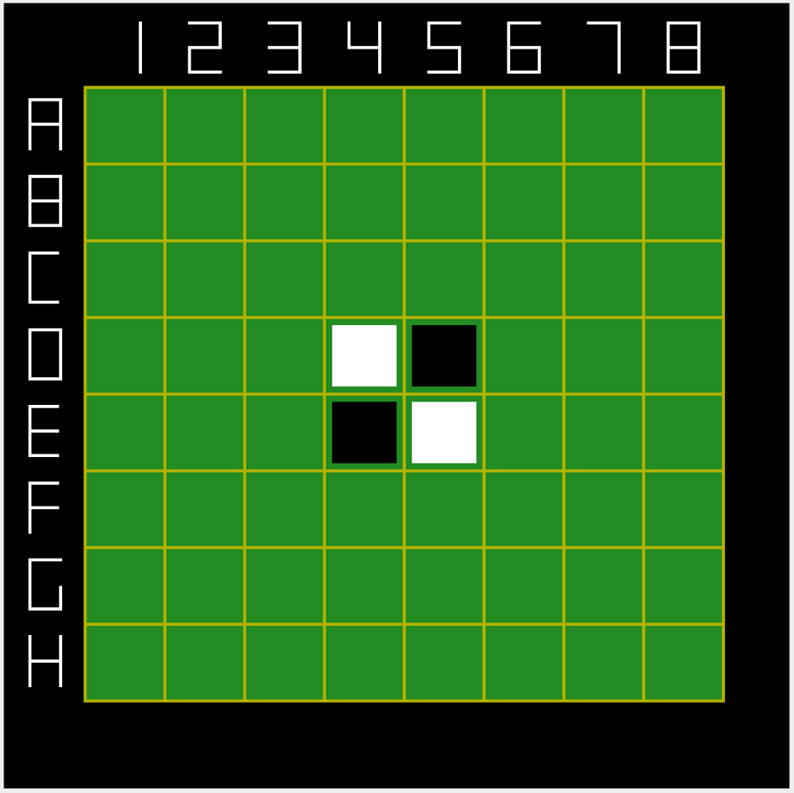

Fig. 1 Initial board.

Black always plays first with players then taking alternate turns. At each turn a player must place a disc with their color face up on one of the empty squares of the board, adjacent to an opponent’s disc such that one or more straight lines (horizontal, vertical or diagonal) are formed from the newly placed disc, through one or more of the opponent's discs and up to other discs of their own color already on the board. All the intervening discs of the opponent’s color are flipped to the color of the newly laid disc.

Discs may be flipped from one color to the other but once played are not moved from one square to another or removed from the board. See Fig.2.

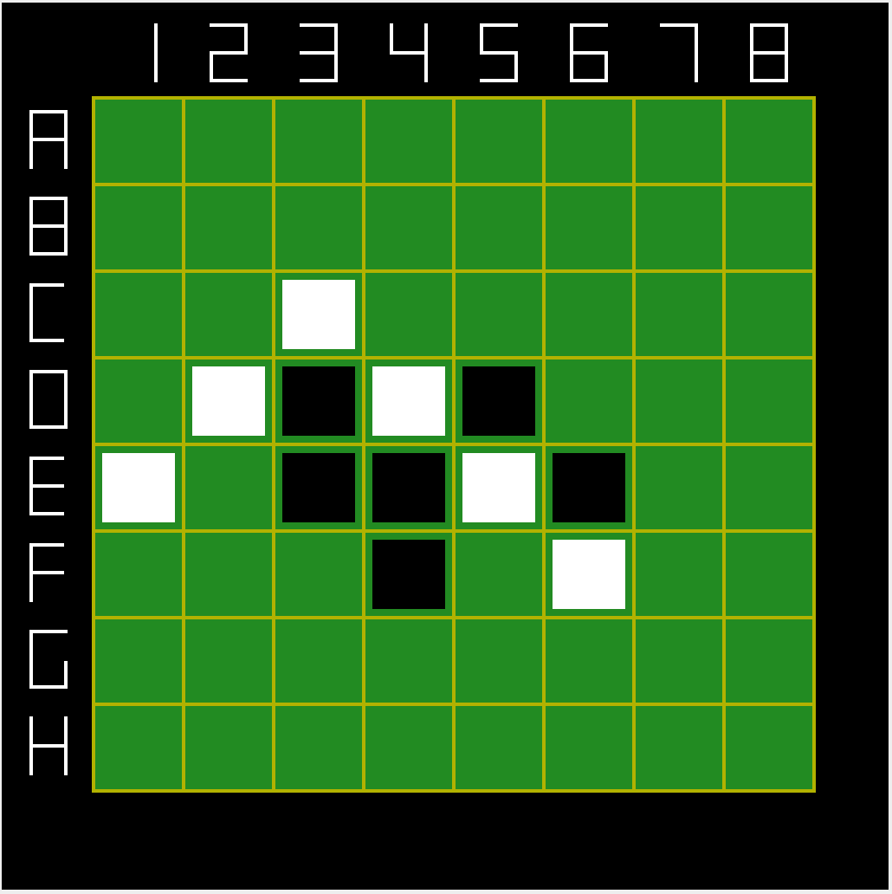

Fig. 2 Game moment.

Players may not pass unless there is no valid move available to them in which case they must pass.

Play continues until neither player is able to move, usually when all 64 squares have been played.

If a player cannot outflank and flip at least one opposing disc, they forfeit their turn and their opponent moves again. However, if a move is available a player may not forfeit their turn.

When it is no longer possible for either player to move, the game is over. See Fig.3.

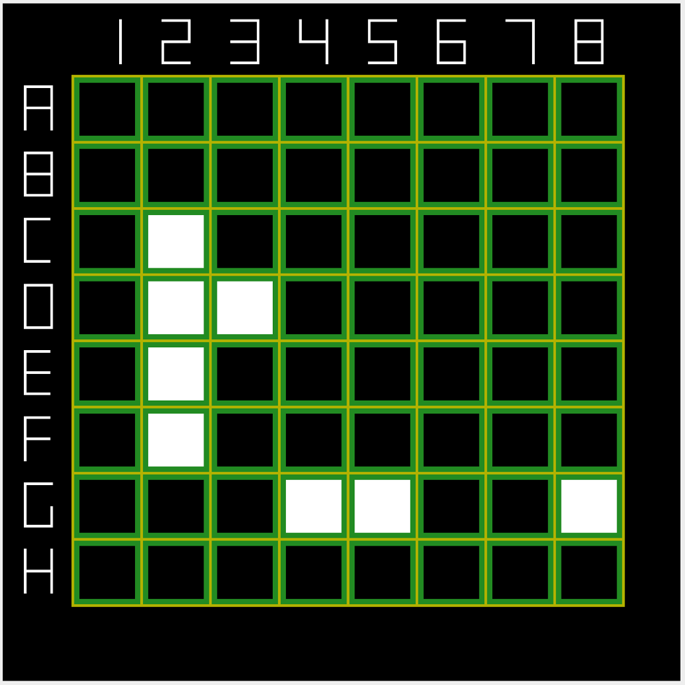

Fig. 3 Game over.

II. Setting up the game

A. open a game file

To execute this game you need a MIPS Assembler and Runtime Simulator – MARS. Run MARS and from the top menu select “File” then “Open” and open the file named rembler_reversi.asm. This will load the game in to the MARS.

B. bitmap display setup

In order to see a game board you should setup a bitmap display in MARS. Click on “Tools” and select “Bitmap Display”. See Fig.4.

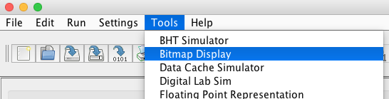

Fig. 4 Bitmap display.

Select value of “4” for both “Unit Width in Pixels” and “Unit Height in Pixels”. Select value of “1024” for both “Display Width in Pixels” and “Display Height in Pixels”. Click “Connect to MIPS”. See Fig.5.

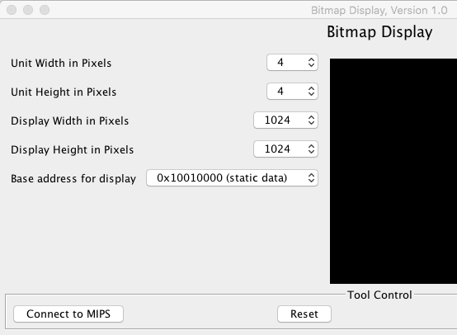

Fig. 5 Units setup.

C. execute the program

After all preparations are complete, now it is time to execute the program to run the game. Click on “Run” from the top menu, then select “Assemble” and after that click “Go”.

III. Playing the game

A. selecting opponents

At the beginning of the game, the player should select an opponent. There are human versus computer and human versus human modes of the game available. See Fig.6.

* If you want to play against a human (2-player game), please enter 1.
* To play against the computer enter any other number.

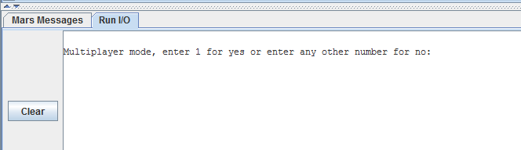

Fig. 6 Game mode.

B. entering player’s name

After selection of the play mode, the player or players are asked to enter their name(s). The names will be used for messages during the game and for statistical information at the end of the game. See Fig.7.

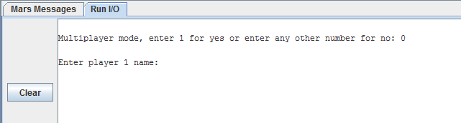

Fig. 7 Player’s name.

C. making moves

The squares on the Reversi board are referred to using coordinate notation. See Fig.8.



Fig. 8 Coordinate notation D3.

To make a move the player must use the program console to enter the coordinates as a letter plus a number combination. The letters are not case sensitive. See Fig.9.

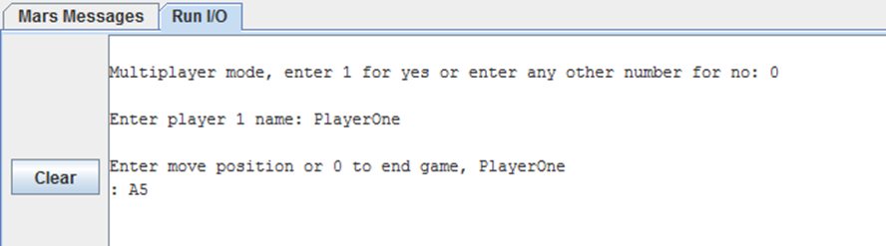

Fig. 9 Entering move A5.

If the player makes an invalid move, the program displays a message that the move is invalid along with the explanation why. In such case, the program also plays a waring sound.

D. final scores

At the end of the game, the program calculates how many black and how many white discs are present on the board. This will become a game score.

Upon the completion of the game, computer also shows the duration of the game.

E. terminating game / starting another game

Entering zero at any moment terminates the current game and prompts the player to either play another round or quit the program completely.

happy playing!